RECOMMENDATION TO WRITE AN ABSTRACT FOR THE UKMHD2024

First Author¹, Second Author² & Third Author²

¹Department, University, City, State
²Department, University, City, State

Keywords — keyword 1, keyword 2, keyword 3, keyword 4

This template for the UK MHD 2024 shall be used for the preparation of the abstract when using MS Word. The maximal length for the abstract is one page including all figures, which are optional. Please note that abstracts longer than one page will not be accepted.
The presenting author should be underlined. A superscript number associated with a given affiliation should be addressed to each. If two or more authors have the same affiliation, the same superscript number related to the given affiliation should be used.
The format of this abstract should comply with the following requirements. The paper size is A4 a text height and width of 245 and 170 mm respectively. The Font to be used is Times New Roman, with justify alignments. The font sizes are 12pt for the title, 11pt for the author list, the keywords, figure captions and the text and 9pt for references. The title should be in bold.
The references are manually entered. Only the surname of the author should be used and if more than two authors "et al." should be used. The title of the reference is given in italics, followed by the journal name. The volume of the article in bold followed by the year in parenthesis should be next given. See the example below.

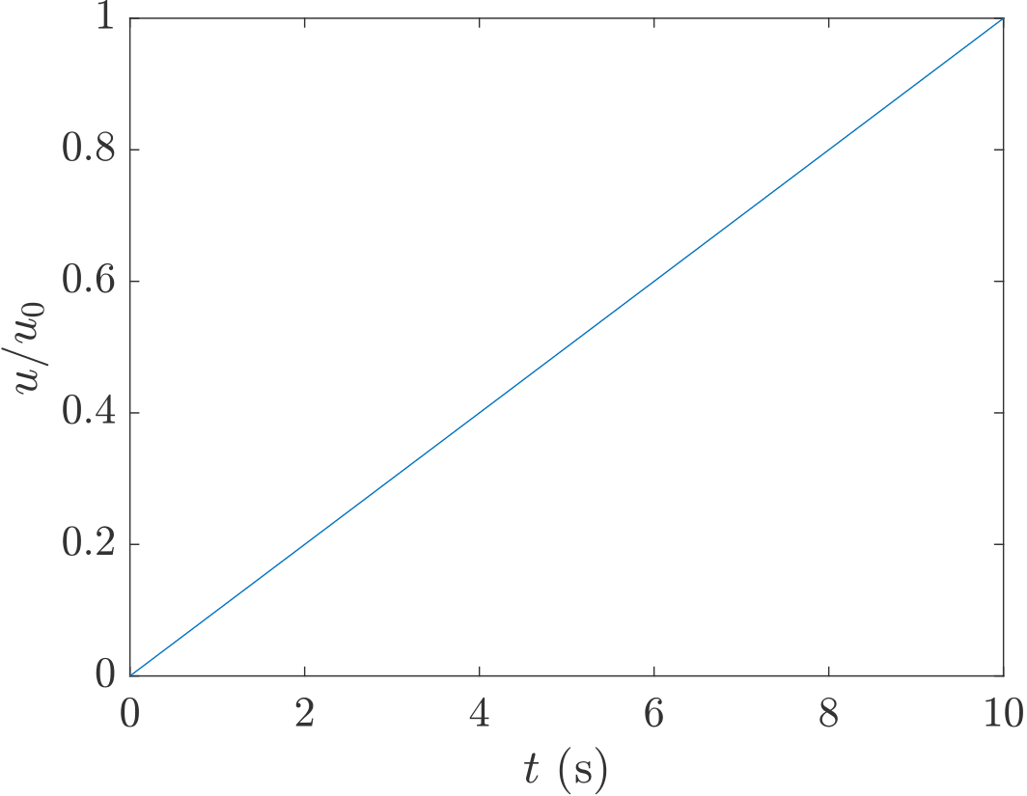

Figure 1. Normalised velocity against time

References

[1] First author, Title, Journal Volume (year).
[2] First author et al., Title, Journal Volume (year).

